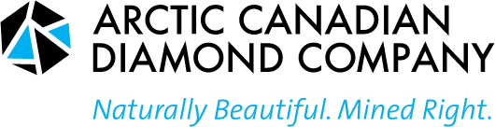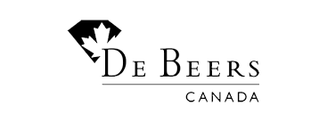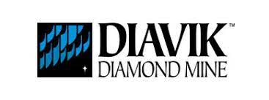

The North Slave Metis Alliance acknowledges and thanks the three Diamond Mines
for the generous support they have provided the Métis of the North Slave Region.
This support has enabled these Métis students to acquire the Education and
Skills needed that will enable them to create fulfilling careers
in their Traditional Homeland.

NORTH SLAVE MÉTIS ALLIANCE

Scholarship Application Form

Deadline:

Please submit completed applications to:

North Slave Métis Alliance
P .0. Box 2301

Yellowknife, XlA 2P7

Tel: (867) 873-6762, Fax: (967) 669-7442

Email: general @nsma.net

Drop off for applications is the Receptionist Desk, at the NSMA Office,
Location: 32 Melville Drive, Kam Lake, Yellowknife

NORTH SLAVE MÉTIS ALLIANCE

Scholarship Application Form

Purpose of the Scholarship Funding:

The North Slave Métis Alliance Scholarship (NSMA) Program is designed to encourage and primarily support North Slave Metis Alliance Métis students in getting an education that will enable their entry into, continuance or advancement within the workforce. The funding is not meant for Métis that wish to take courses solely for self-improvement or of interest to them.

The Scholarship will support Métis who are accepted into or are currently attending a university, accredited college, technical school or institute of technology for the purpose of attaining a degree, diploma or certificate or taking a specialized course leading to that.

The funding is not restricted to university level applicants but rather, will also be open to applicants within trades and such other non-university courses or educational offerings.

Criterion:

The Applicant must be of Métis descent, and primarily a NSMA “Community” member and generally a resident in the North Slave Region of the Northwest Territories. The following documents must accompany the completed application form: (see page 4 for complete listing)

- A written application and rationale outlining why they are applying for a scholarship from the North Slave Métis Alliance;
- A clear budget, schedule of activities and other evidence that is well organized, easily readable, and that supports their application.
- Written proof of acceptance for the current semester stating you are enrolled as a full-time student at a university, accredited college, technical school or institute of technology or such course that will enable their career advancement or entry to the workforce;
- For University Students, transcript(s) of previous academic performance must be submitted; and two letters of reference should accompany the application.
- In the case where the applicant was unsuccessful in a past course or semester, the applicant shall provide the full reasons and may be interviewed to establish whether that student shall be funded.

Preference will be given to Métis students who:
- Are from the North Slave Metis Alliance “Community” and may include those who are not directly residing within the NWT.
- Have a proven financial need and have not received financial assistance from other Metis or First Nation financing sources and other than GNWT or Canada Funding;
- Show that their courses and other academic undertakings will reasonably enable entry, continuance and advancement into the workforce and are not simply courses meant as self-improvement courses.
- Have a strong academic background or workplace record of achievement.
- Who may have been held back from becoming eligible student applicants due to personal circumstance such as long-term homemaker, illness, or other former employment;

A scholarship recipient must re-apply each academic year or for each specialized course. The recipient must submit ALL REQUIRED INFORMATION and will be considered on individual merit in each academic year.

Please note that incomplete applications may not be considered for review. (Refer to the checklist provided on page 4 of this application form for submission requirements.

All applications will be assessed on an individual basis and all decisions made by the scholarship committee are final.

NORTH SLAVE MÉTIS ALLIANCE
Scholarship Application Form

Section 1- Personal Information (please print)

Full Name: Permanent Mailing Address: ____________

Phone: (home) _

(Alternate) _

Email Address:

*** Please attach a photocopy of your current NWT Health Care Card ***

Section 2 – Post Secondary Education (Please Print)
Name of Post-Secondary Institution:
Address & Phone# while at school:

Name of Program currently enrolled in:
Length of Program:
Expected Date of Graduation:
Highest Level of Education completed to date:
Certificate Diploma Degree Other

Please list all other scholarships I Bursaries I Grants, including their dollar amounts that you have received or will receive this year. (Please include SFA.)

NSMA REVIEW SECTION

□ Approved □ Not Approved

(Signature of NSMA Committee Member) (Date)

_________________________________ ________________________________

APPROVED FUNDING | ARCTIC CANADIAN DIAMONDS | DEBEERS CANADA | DIAVIK-RIO-TINTO
Funded $: | Funded $: | Funded $: | Funded $:

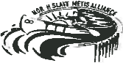

NORTH SLAVE MÉTIS ALLIANCE
Scholarship Application Form

Section 3 - Application Check List

Please ensure that prior to the submission of your application, the following checklist is filled out and all documentation is included with your application package. Incomplete Applications may not be considered for review.

Applicant's Name:

Check each item as you go through the Check List
Application form completed
Indigenous Métis and proof of residency in North Slave area (i.e. copy of bill statement, current receipts with your name on it, etc.)
Written Rationale
Letter from School stating you are currently enrolled as a full-time student
Transcript(s)
Financial need indicated
Letter of Reference 1
Letter of Reference 2
Photocopy of current NWT Health Care Card

If the applicant is unable to produce one or more of the above mandatory documents, please state
the reasons below:

Completed applications are to be submitted to the North Slave Métis Alliance no later

than 2023
Day Month

North Slave Métis Alliance
P.O Box 2301
Yellowknife NT XlA 2P7
Ph. (8.67) 873-6762 Fax (867) 669-7442
Email; general@nsma.net

Drop off for applications is the Receptionist Desk, at the NSMA Office,
Location: 32 Melville Drive, Kam Lake, Yellowknife

